Clipping Box Tops is an easy way to help earn cash for our school.
Each one is worth 10¢ for our school! Just look for the pink Box Tops on hundreds of products.

Last school year, we earned $621 for our school from Box Tops and used the money for Para-educators. This school year, our goal is to earn $1,000.

We have two drives through the school year to collect box tops:
- The class with the most box tops submitted for each deadline will receive a spirit day of their choice.

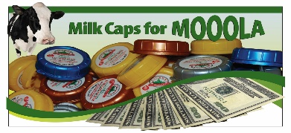
Trails West earns MONEY for your Longmont Dairy milk caps. Simply wash and deposit in the bin by the cafeteria.

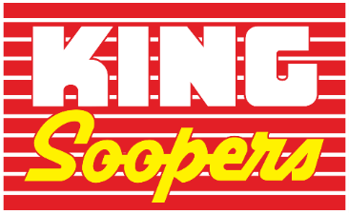
King Soopers Rewards Card
Visit https://www.kingsoopers.com/topic/king-soopers-community-rewards. Click “Enroll Now”
Once logged into your King Soopers account under “Find an Organization” search for Trails West Elementary PTO either by name or EI349 and then click Enroll.
* New users will need to create an account which requires some basic information, a valid email address and a loyalty card. **Customers must have a registered King Soopers loyalty card account to link to our organization

Shopping at Amazon? Change you search
Engine to smile.amazon.com and select Trails West as your charity.

- - - - - - - - - - - - - - - - - - - - - - - - - - - - - - - - - - - - - - - - - - - - - -- - - - - - - - - - - - - - - - - - - - - - - - - - -

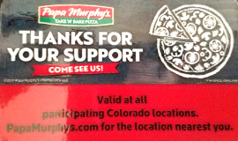
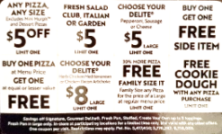
PAPA MURPHY CARDS
Make great gifts!! Purchase a couple for yourself or
to share with neighbors or family. Each card pays for itself after 1 use.

Student: ___________________ Teacher: ___________# of Card____X $10
Checks made payable to Trails West PTO. Cards will be delivered to students as orders are received.

